* [HOME](https://variety.com/)
* [TV](https://variety.com/v/tv/)
* [NEWS](https://variety.com/c/news/)

Feb 16, 2023 1:09pm PT

# [Ice-T Talks Bringing Street Cred to ‘Law and Order: SVU,’ Friendship With Mariska Hargitay and Connecting With Dick Wolf on a ‘Gangster Level’](https://variety.com/2023/tv/news/ice-t-law-and-order-svu-mariska-hargitay-dick-wolf-1235525740/)

**By** [**Emily Longeretta**](https://variety.com/author/emily-longeretta/)

Plus Icon

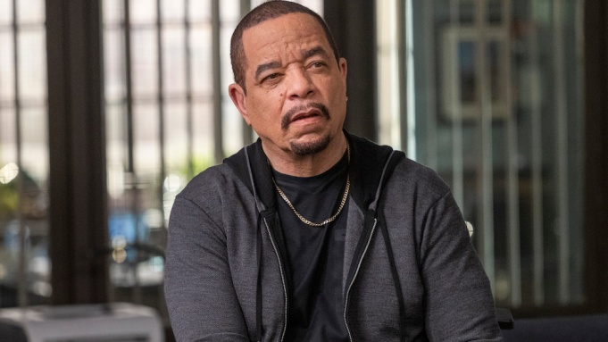

Scott Gries/NBC

Although he may be best known for his [successful music career](https://variety.com/2023/music/news/ice-t-hollywood-walk-of-fame-state-of-hip-hop-1235523271/), [Ice-T](http://variety.com/t/ice-t) is also on the television of millions every Thursday night.

Acting has been in his blood for years, as he had his breakout role in “New Jack City” in 1991, followed by “Surviving the Game” in 1994. However, it was the next year he met the man who changed his TV career. In 1995, Ice-T landed a recurring role as a drug dealer on [Dick Wolf](https://variety.com/t/dick-wolf/)’s “New York Undercover,” beginning their professional collaborations. After, he co-created “Players,” with Wolf as the producer, but that didn’t last. So, Wolf gave him a part in 1998’s “Exiled: A Law & Order Movie.”

Two years later, the world was introduced to Odafin “Fin” Tutuola in Season 2 of “[Law & Order: Special Victims Unit](https://variety.com/t/law-and-order-svu/),” on which he’s appeared in more than 400 episodes.

“I think that I am his longest- running employee,” says Ice-T, who recalls getting a call from the late Andre Hall, a producer on “New York Undercover.”

“I told Andre, ‘Fuck you.’ I had just come off of ‘New Jack City’ in film, and didn’t need TV. Friendly though, like ‘Motherfucker, I don’t do television. I’m a movie star,’” he laughs. “They gave me the whole ‘C’mon, you too big, now’ routine. So, I told Andre to give me a bad guy role and they found one in a character named ‘Danny Up.’”

When he showed up, Ice-T was told the plan originally was to kill the character after one episode; instead, they wanted him for more.

After “Players” didn’t work, “Dick Wolf said that he wished he would’ve had a stronger vehicle for me.” While he was moving on post-cancelation, he got the call for “SVU.”

And at first, he said no.

“They wanted me to come out there and only do four episodes. At the time, I was trying to run a record label, so I was like, ‘Eh,’” he recalls. “Four episodes turned into 24 years.”

And those two dozen years have been a joy for everyone on the show including star and executive producer Mariska Hargitay.

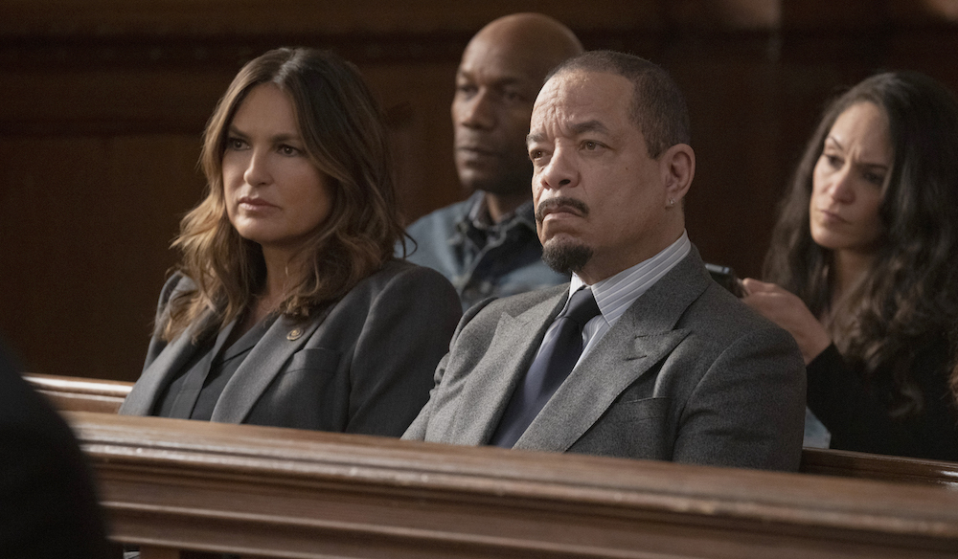

Virginia Sherwood/NBC

“I can’t say this about a lot of people — not even myself! — but in the 24 years we’ve been working together, he’s never come to the set in a bad mood, and he’s never complained,” she says. “And he’s got some stiff competition, but he might just lead the pack in gratitude for the incredible gift of being able to do this show for all these years.”

When he joined the series, Ice-T didn’t know anyone on set.

“I took them to the side one day and told them. … ‘You gotta understand who I am. I used to rob banks in real life. If I’m robbing a bank, I don’t need to like you. I just need to know if you can get into a safe, control a room, scan the radio and drive. Once we rob a few banks together, we’ll become the best fucking friends. Ever.’ Now, Mariska and I have been robbing them banks for 24 years,” he says. “I always tell Mariska that I’ve got my life, wife and my daughter, but that I make more money with her, so Mariska’s got to know where she ranks in my life. Do not come fucking with Mariska.”

As Hargitay remembers, she was “intimidated” when Ice-T joined, since she knew him as an artist and trailblazer. She quickly realized how special he was — “someone deeply true to his principles, kind, wise and just ridiculously generous.”

“I think what surprised me most was the gentleness,” she adds. “He’s a wonderfully curious, principled, loyal, gentle spirit.”

The bond between Ice-T and his work family has only continued, both on and off screen.

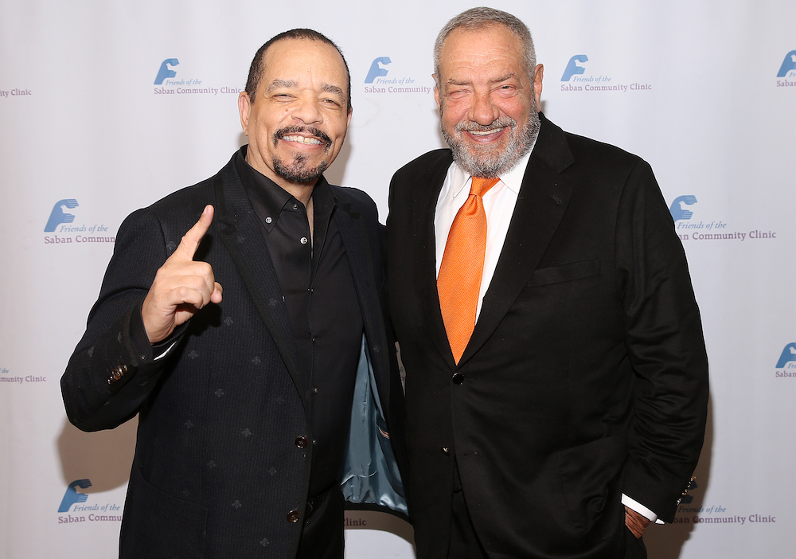

Getty Images

“Me and Dick Wolf connect on a very gangster level. He’s the boss. I’m part of his organization. He’s never lied to me. He’s always paid up. When he makes an agreement with me, he sticks to the agreement,” he says. “I’m not just an actor. I am an activist. I am Body Count. So, if he has a Black card in his deck, it’s Ice-T. Any motherfucker comes at him about anything Black, he can say that he’s got motherfucking Ice-T on his show. Get the fuck up out of here. If I’m his token Black man, he knows he’s got a real one.”

A man of few words, Wolf has one thing to say about the actor: “Ice has been the gold standard for the past 28 years.”

And he has no plans to slow down or shift out of television. In film, he recalls, he filmed two or three scenes in a day. Now, he’s doing nine to 10 on “SVU,” which he a “bootcamp” for actors.

“To be on a show this long, is like having gone to Harvard and grad school and getting my Ph.D, because every day I’m acting,” he says — and is no longer nervous alongside any A-list actor. “I know whatever they can bring, I can bring right back at them. … Working with an F. Murray Abraham, he told me to learn from the actors I work with and that’s the best training. That’s where I’m going to get my stuff. So now, I’ve worked with everybody from Jerry Lewis to Bradley Cooper. They all come through the doors of ‘SVU’ and I learn something from every one of them.”

**TIPSHEET**

WHAT: Ice-T receives a star on the [Hollywood Walk of Fame](https://variety.com/t/hollywood-walk-of-fame/).  
WHEN: 11:30 a.m. Feb. 17  
WHERE: 7065 Hollywood Blvd.  
WEB: [walkoffame.com](http://walkoffame.com/)

*With reporting by A.D. Amorosi*.